Political Regime, Reproductive Health Outcomes, and FemTech Privacy: An Exploratory Two-Strand Assessment
Jolie [Lastname]¹*
[Institution Name]¹
*Corresponding Author. Email: [student email]
Abstract: FemTech applications now reach large numbers of users. Those users live inside political and economic settings that shape reproductive health, and this paper treats the two as separate questions. The first strand draws on 167 countries, built from World Bank indicators and the V-Dem political-regime classification distributed by Our World in Data. Models that adjust for income cover 166 countries for maternal mortality and 138 for contraceptive prevalence. The sample shrinks for two reasons: 28 countries have no contraceptive estimate, and the archived regime series reports no single 2023 value for Palestine. In bivariate terms, regime category correlated with log maternal mortality at r = -0.44 and with contraceptive prevalence at r = 0.45. Income adjustment changed the picture. The mortality association became small and imprecise, at beta = -0.053 (HC3 95% CI -0.202 to 0.095; conventional p = .504; HC3 p = .481). The contraceptive association held in the primary model, at 4.83 percentage points per category (HC3 95% CI 0.91 to 8.75; conventional p = .0047; HC3 p = .016). The association was smaller and imprecisely estimated in a sample limited to 2015-2023 observations (beta = 3.27, HC3 95% CI -1.42 to 7.95; HC3 p = .170). The privacy review covers audits and two Federal Trade Commission cases, without pooling them and without linking them to the country results. Taken together, the findings support precautionary privacy oversight and better measurement. They do not support a causal claim about data governance.
Keywords: FemTech; reproductive health; political regime; maternal mortality; contraceptive prevalence; privacy; ecological analysis

Introduction
FemTech has grown from a niche label into a large consumer-health sector. One commercial market report valued the sector at US$39.29 billion in 2024 and projected US$97.25 billion by 2030, a compound annual growth rate of 16.3% [9]. As of June 2024, Flo reported nearly 70 million monthly active users [16], and the company states that more than 380 million people have downloaded the app [15]. Those numbers show scale. They come from company self-reports and a commercial forecast, so they say little about population health.
The public-health case still matters. Reproductive-health applications can widen access to symptom tracking, cycle information, pregnancy support, and health education. They also collect intimate information that never enters a clinical record. Both deserve attention. A model built on country-level health data cannot show what one application sent to an advertising platform, and an audit of one application cannot establish national health effects.
This paper keeps the two questions apart. Strand 1 asks whether political regime type is associated, at country level, with maternal mortality and contraceptive prevalence, before and after adjustment for national income. Strand 2 asks what selected independent reviews and regulatory cases show about privacy risks in FemTech and in nearby health applications. The two strands belong in one paper because both concern the institutional setting of digital reproductive health. No test in this paper connects them at country level.

Background
Digital tools for women's health grew while research on women's health remained underfunded. An editorial in Nature Reviews Bioengineering reported that research and development directed at women's health made up roughly 5% of the global total, and that FemTech funding reached about US$2.5 billion in 2021, or some 3% of digital-health funding [10]. The National Institutes of Health devoted about 10.8% of its budget to women's health research in fiscal year 2020, or $4,466 million [12]. A related editorial discusses the same gap from the side of device and study design [11]. The World Health Organization estimates that endometriosis affects about 190 million reproductive-age women and girls, and that polycystic ovary syndrome affects roughly 10-13% of reproductive-age women [13, 14]. These figures explain why tools that extend information and self-management attract attention.
Population-level reproductive outcomes follow steep economic and institutional gradients. The WHO estimated that the global maternal mortality ratio fell from 339 deaths per 100,000 live births in 2000 to 223 in 2020, with wide regional gaps still in place [1]. Any cross-country analysis therefore has to adjust for national income. It also has to resist reading a broad political measure as if it were a specific health-data law. The Regimes of the World measure sorts country-years into closed autocracy (0), electoral autocracy (1), electoral democracy (2), and liberal democracy (3) [3]. That is a measure of political regime. It leaves out privacy protection, health-system quality, gender equality, and enforcement capacity.
Privacy studies answer a different question. Mozilla's 2022 review applied its warning criteria to 25 products, 20 of them period or pregnancy applications and five wearable devices, and flagged 18 [4]. Grundy and colleagues examined network traffic from 24 medicines-related Android applications and found that 19 sent user data outside the application ecosystem [5]. That study was peer reviewed. Its sample was not a reproductive-health-application sample. Federal Trade Commission actions against Flo and Premom add case evidence of alleged disclosures and of regulatory response [6, 7]. Together these sources document real and specific risks. Their denominators, methods, locations, and endpoints differ too much to be combined into one percentage.

Methods
The country is the unit of analysis. The analytic sample is 167 countries. Maternal mortality ratio is the modeled number of maternal deaths per 100,000 live births. Contraceptive prevalence is the World Bank indicator for use of any method among married women aged 15-49, not the modern-method indicator. GDP per capita is measured in purchasing-power-parity terms, in constant 2021 international dollars [2]. For each of the three indicators the worksheet takes the latest non-missing observation between 2010 and 2023 and records the year it came from. GDP enters the models as a natural logarithm.
Political regime comes from the V-Dem Regimes of the World classification, four categories distributed by Our World in Data [3]. The analysis fixes the source to the OWID archive dated 5 August 2026 and uses the 2023 classification. Within the analytic sample of 167 countries, the 2023 classification gives 27 closed autocracies, 51 electoral autocracies, 55 electoral democracies, and 33 liberal democracies. The archived file lists Palestine/Gaza and Palestine/West Bank separately and supplies no unified 2023 figure, so PSE stays visible in the country worksheet but drops out of any model that needs regime type. That is why the maternal-mortality sample is 166.
The main maternal-mortality model is ordinary least squares, with log(MMR) as the outcome and political-regime category and log GDP as predictors. Treating 0 to 3 as a linear trend imposes equal spacing: every one-category step is assumed to carry the same increment. Two sensitivity models relax that. One replaces the trend with three category indicators, using closed autocracy as the reference. The other keeps the trend but uses untransformed MMR. The main contraceptive model uses the same ordinal regime trend and log GDP. Contraceptive prevalence is available for 139 of the 167 countries, and 138 countries have both a prevalence estimate and a unified regime score.
Contraceptive data are patchy in time as well as in coverage. Each country contributes its most recent value from 2010 to 2023; the median observation year is 2018, and the interquartile range is six years. Two sensitivity checks address this. One restricts the sample to observations from 2015 to 2023. The other adds observation year, centered on 2018, as a predictor. The restricted sample holds 109 countries after merging with regime. Complete-case estimation cannot repair outcome data that are missing for systematic reasons, so missingness is reported by regime category and by country.
Every model reports the coefficient, the conventional standard error, a two-sided p value from the t distribution with residual degrees of freedom, HC3 standard errors, HC3 confidence intervals, R-squared and adjusted R-squared. HC3 standard errors are used for the main statistical inference, because variance may differ across countries. Conventional results stay in the table for comparison. Statistical significance within a model and robustness across specifications are reported separately. The two are not combined into one label. An estimate with an HC3 p value from .05 to .10 is described as borderline. One at .10 or above is described as imprecisely estimated.
The privacy review is a structured evidence matrix, not a meta-analysis. For each source it records the object studied, the platform, the region, the sample size, the numerator and denominator where they mean anything, the endpoint, the method, the type of evidence, the limits on comparability, the source link, and any documented follow-up. Mozilla warning labels, observed network transmissions, and FTC enforcement cases are not converted into a common percentage. Flo's statement that it completed the independent review required by its FTC order, in March 2022, is recorded as a company-reported follow-up [8].

Results
Maternal mortality is heavily right-skewed. Across 167 countries the median was 41 deaths per 100,000 live births, the mean was 116.9, and the range ran from 1 to 993. Median contraceptive prevalence among the 139 countries with an estimate was 54.6%, ranging from 6.9% to 85.5%. Regime category had a moderate negative bivariate correlation with log maternal mortality (r = -0.441, n = 166) and a moderate positive correlation with contraceptive prevalence (r = 0.446, n = 138). Log GDP correlated more strongly with log maternal mortality (r = -0.850, n = 167) and positively with contraceptive prevalence (r = 0.575, n = 139). Regime category and log GDP were themselves correlated (r = 0.489, n = 166). That overlap makes income a possible confounder.
Figure 1 plots the bivariate mortality gradient across the four categories. Median log(MMR) declines as regime category rises, but the country points overlap heavily at every step. Figure 1 also shows wide differences among countries in the same category. Regime type neither determines nor closely predicts one country's maternal mortality burden.
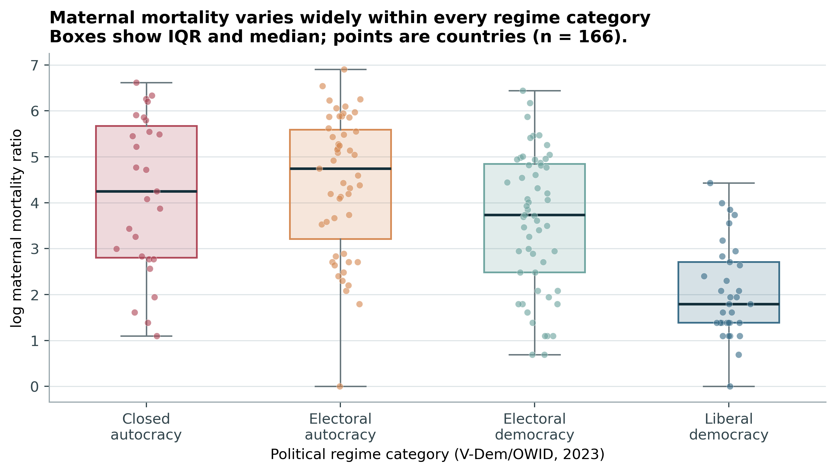
Figure 1. Distribution of log maternal mortality ratio across four political-regime categories, 2023 regime classification.
In the main income-adjusted model, a one-category rise in regime score predicted -0.053 log points of maternal mortality (conventional SE 0.079, p = .504; HC3 SE 0.075, p = .481; HC3 95% CI -0.202 to 0.095). R-squared was .731 and adjusted R-squared .728. Log GDP carried a large negative coefficient of -1.203, with an HC3 p value below .001. Two sensitivity models pointed the same way. Untransformed MMR gave -3.49 deaths per 100,000 per category, with an HC3 p value of .707. With regime split into three indicators, none of the three contrasts against closed autocracy was statistically significant. After income adjustment the mortality coefficient was attenuated toward zero and imprecisely estimated.
The contraceptive side looked different. Each one-category step toward liberal democracy was associated with 4.83 percentage points higher contraceptive prevalence after adjustment for log GDP (conventional SE 1.68, p = .0047; HC3 SE 1.98, p = .016; HC3 95% CI 0.91 to 8.75). R-squared was .373 and adjusted R-squared .363. Adding observation year barely moved the coefficient, to 4.80 points with an HC3 95% CI of 0.79 to 8.82 and p = .019. The primary estimate was statistically significant with HC3 standard errors.
Table 1. Income-adjusted political-regime estimates across primary and sensitivity models.
Outcome / specification | n | beta | Conventional SE | Conventional p | HC3 SE | HC3 p | HC3 95% CI | R2 / adj. R2
log(MMR), ordinal trend (primary) | 166 | -0.053 | 0.079 | .504 | 0.075 | .481 | -0.202, 0.095 | .731 / .728
MMR raw scale, ordinal trend | 166 | -3.49 | 10.62 | .743 | 9.25 | .707 | -21.74, 14.77 | .520 / .515
CPR 2010-2023 latest (primary) | 138 | 4.83 | 1.68 | .0047 | 1.98 | .016 | 0.91, 8.75 | .373 / .363
CPR plus observation year | 138 | 4.80 | 1.69 | .0051 | 2.03 | .019 | 0.79, 8.82 | .373 / .359
CPR restricted to 2015-2023 | 109 | 3.27 | 2.02 | .108 | 2.36 | .170 | -1.42, 7.95 | .342 / .329
Notes: beta is the coefficient for a one-category increase in political regime (0-3), adjusted for log GDP per capita. HC3 standard errors are used for the main statistical inference; conventional results are reported for comparison. All p values use a two-sided t distribution with residual degrees of freedom.
The timing check qualified that estimate. Among the 109 countries with a contraceptive observation from 2015 to 2023, the coefficient fell to 3.27 points and lost precision (HC3 95% CI -1.42 to 7.95, p = .170). The categorical version told a similar story. The electoral-democracy contrast was 10.61 points with an HC3 p value of .040. The liberal-democracy contrast was 12.48 points with an HC3 p value of .053, which is borderline. The electoral-autocracy contrast was imprecisely estimated. The direction stays positive across specifications, and the size of the estimate moves with time coverage and with coding.
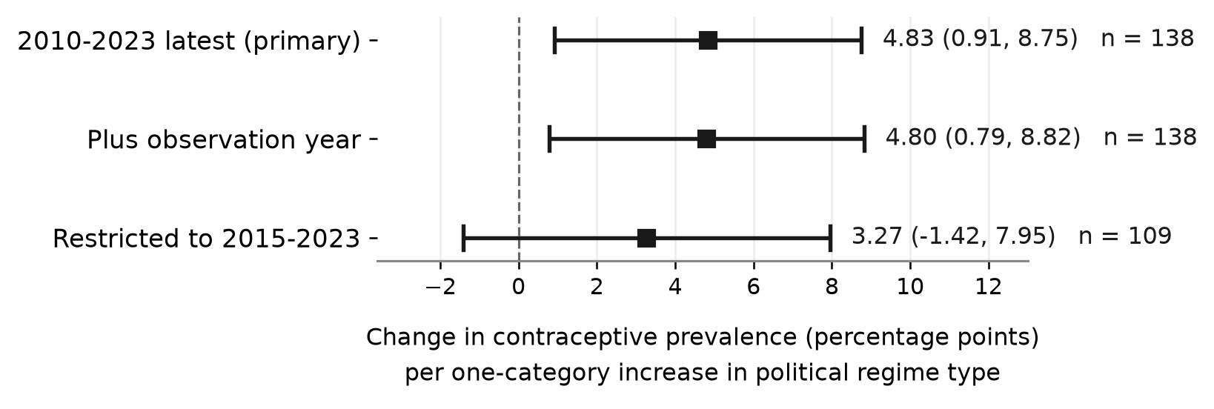
Figure 2. Contraceptive-prevalence estimates across three specifications, with HC3 95% confidence intervals. The dashed line marks zero. The coefficient is for a one-category increase in political regime type, adjusted for log GDP per capita.
Contraceptive prevalence is missing for 28 of the 167 countries. The missing values are not spread evenly. By regime category, the counts were 3 of 27 closed autocracies (11.1%), 4 of 51 electoral autocracies (7.8%), 10 of 55 electoral democracies (18.2%), and 11 of 33 liberal democracies (33.3%). The concentration in the liberal-democracy group makes a missing-completely-at-random assumption hard to defend. HC3 recalculates uncertainty under heteroskedasticity. It does nothing about selection.
The privacy matrix supports a narrower statement. Mozilla's count of 18 out of 25 reflects its own warning framework, and five of the 25 products were devices, not applications [4]. The BMJ result of 19 out of 24 concerns medicines-related Android applications and directly observed data sharing [5]. The FTC records cover two individual cases, Flo and Premom [6, 7], and Flo later stated that it completed the independent privacy review its order required [8]. These records show that intimate health-data practices have drawn credible scrutiny and enforcement. They do not measure a global FemTech failure rate.
Table 2. Privacy evidence matrix: distinct endpoints and limits.
Source | Object / endpoint | Evidence | Comparability limit or follow-up
Mozilla (2022) [4] | 20 apps + 5 devices; 18/25 received a Mozilla warning | Independent civil-society review | Warning criteria are not observed transmission; devices included
Grundy et al. (2019) [5] | 24 medicines-related Android apps; 19 shared data outside app ecosystem | Peer-reviewed traffic/network study | Not a reproductive-health sample; endpoint differs from Mozilla
FTC: Flo (2021) [6] | Individual fertility-app enforcement case | Regulatory order | Not a prevalence estimate; Flo reports March 2022 independent review [8]
FTC: Premom (2023) [7] | Individual ovulation-app enforcement case | Regulatory action | Not a prevalence estimate; later compliance not independently assessed here

Discussion
Political regime type has visible bivariate gradients with both reproductive-health outcomes. After income adjustment the mortality coefficient moved toward zero and was imprecisely estimated. The contraceptive coefficient stayed positive and statistically significant in the primary model. That result is not robust across every specification. It survives HC3 and adjustment for observation year, but it loses statistical significance in the smaller and more recent sample and shifts across categorical contrasts. Across these specifications the pattern is a positive association that is significant in the main model and sensitive to the observation window.
The mortality model cannot prove that there is no association. The adjusted estimate is small and uncertain. After GDP adjustment the coefficient is small next to its own uncertainty, and neither the alternative outcome scale nor the categorical coding restores a clear signal. The attenuation is consistent with confounding by income. A coarse political proxy and the limits of the model could also account for it. Regime type and income are moderately related (r = .489). The adjusted mortality coefficient is much smaller than the bivariate one, which suggests that most of the bivariate pattern overlaps with income differences. What matters more is what the measure leaves out: health-system capacity, conflict, gender inequality, service access, legal protection, and implementation quality.
Several factors may explain the positive association with contraceptive prevalence. Democratic accountability and women's autonomy may affect access to contraception. Education, health services, and economic development may also matter. Older survey years and the missing data described above could play a part too. The indicator itself is narrow. It counts any method among married women aged 15 to 49. Access for other reproductive-age people is missing from it, and the indicator cannot separate an informed choice from a coerced one. Causal claims and value judgments go beyond what these data support.
The privacy strand supplies evidence at another level. Product audits and enforcement cases show that sensitive reproductive or medicines-related data can travel outside the context users expect. That justifies closer attention to consent, data minimization, deletion, third-party software development kits, and independent verification. The matrix also shows why a single bar chart would mislead. A Mozilla warning label, observed BMJ network traffic, and an FTC allegation are three different endpoints measured three different ways. No pooled percentage is reported, and none is warranted.
Putting both strands in one paper is defensible only while the boundary between them stays visible. The country models describe ecological associations between a broad political classification and two health outcomes. The privacy sources describe product-level and case-level risks, mostly in particular market and regulatory settings. This study has no national FemTech adoption measure and no country-level privacy-exposure measure. It cannot test whether application practices explain population outcomes.
Policy conclusions should match that evidence. Regulators do not need to read the country coefficient as a demonstrated effect of privacy law. The application cases and audits stand on their own, and they support precautionary requirements: clear consent, purpose limitation, data minimization, breach notification, and checks that the required changes were completed. The cross-country findings point to a different kind of investment. Better measurement would help most: a dedicated health-data-protection index, country-level enforcement indicators, representative adoption data, and outcomes tracked over time. Linking those measures in one country-year design is the next step.
The study is exploratory and ecological. It uses one cross-section, a sample of 167 countries that is not exhaustive, mixed observation years for contraceptive prevalence, complete-case estimation, and a four-category expert-coded regime measure. Palestine has no unified regime observation in the archived 2023 series. The privacy evidence was selected on purpose and is heterogeneous. Because the study uses one cross-section, it cannot establish causality. The accompanying workbook lists every source file and its hash, and every sample size and sensitivity result in this paper can be checked against it.

Conclusion
Political regime type tracks both maternal mortality and contraceptive prevalence in bivariate cross-country comparisons, and the two adjusted results then diverge. After income adjustment the mortality coefficient was attenuated toward zero and imprecisely estimated. The contraceptive estimate was positive and statistically significant in the primary model, though it lost significance in a sample restricted to 2015-2023. Both are exploratory ecological patterns. Neither estimates a causal privacy-policy effect.
Independent privacy reviews and FTC cases point separately to real concerns about sensitive health-data practices. They give reasons for further research and for precautionary regulation. Future work should connect validated measures of law, enforcement, application adoption, exposure, and health outcomes at the same analytical level. Until that work exists, the two strands stay separate.

References
[1] World Health Organization. Trends in maternal mortality 2000 to 2020: estimates by WHO, UNICEF, UNFPA, World Bank Group and UNDESA/Population Division. Geneva: WHO; 2023. https://iris.who.int/bitstream/handle/10665/366225/9789240068759-eng.pdf
[2] World Bank. World Development Indicators. API snapshot last updated 13 July 2026; downloaded 3 September 2026. Indicators: maternal mortality ratio (SH.STA.MMRT) https://api.worldbank.org/v2/country/all/indicator/SH.STA.MMRT?format=json&per_page=20000 ; contraceptive prevalence, any method (SP.DYN.CONU.ZS) https://api.worldbank.org/v2/country/all/indicator/SP.DYN.CONU.ZS?format=json&per_page=20000 ; GDP per capita, PPP, constant 2021 international dollars (NY.GDP.PCAP.PP.KD) https://api.worldbank.org/v2/country/all/indicator/NY.GDP.PCAP.PP.KD?format=json&per_page=20000. The snapshot used here cannot be reproduced from the live API after later updates; the workbook records the original file names and SHA-256 values.
[3] V-Dem (2026) - processed by Our World in Data. "Democracy" [dataset]. V-Dem, "Democracy report v16" [original data]. Retrieved 5 August 2026 from https://archive.ourworldindata.org/20260805-143540/grapher/political-regime.html (archived on 5 August 2026).
[4] Mozilla Foundation. In post-Roe v. Wade era, Mozilla labels 18 of 25 popular period and pregnancy tracking tech with Privacy Not Included warning. 17 August 2022. https://www.mozillafoundation.org/en/blog/in-post-roe-v-wade-era-mozilla-labels-18-of-25-popular-period-and-pregnancy-tracking-tech-with-privacy-not-included-warning/
[5] Grundy Q, Chiu K, Held F, Continella A, Bero L, Holz R. Data sharing practices of medicines related apps and the mobile ecosystem: traffic, content, and network analysis. BMJ. 2019;364:l920. doi:10.1136/bmj.l920.
[6] US Federal Trade Commission. FTC Finalizes Order with Flo Health, a Fertility-Tracking App that Shared Sensitive Health Data with Facebook, Google, and Others. 22 June 2021. https://www.ftc.gov/news-events/news/press-releases/2021/06/ftc-finalizes-order-flo-health-fertility-tracking-app-shared-sensitive-health-data-facebook-google
[7] US Federal Trade Commission. Ovulation Tracking App Premom Will be Barred from Sharing Health Data for Advertising Under Proposed FTC Order. 17 May 2023. https://www.ftc.gov/news-events/news/press-releases/2023/05/ovulation-tracking-app-premom-will-be-barred-sharing-health-data-advertising-under-proposed-ftc
[8] Flo Health. Flo's response to the FTC settlement (updated 1 October 2024). The page states that the independent audit required by the order was completed in March 2022. https://flo.health/newsroom/flo-response-ftc-settlement-update
[9] Grand View Research. FemTech Market Size, Share, & Trends Analysis Report By Type (Devices, Software, Services), By Application (Pregnancy And Nursing Care), By End-use (Direct To Consumer), By Region, And Segment Forecasts, 2025-2030. 150 pages; published November 2024. Commercial market forecast. Market value in 2024: US$39.29 billion; forecast 2030: US$97.25 billion; CAGR 16.3%. https://www.researchandmarkets.com/reports/5595800/femtech-market-size-share-and-trends-analysis
[10] Funding research on women's health [editorial]. Nature Reviews Bioengineering. 2024;2:797-798. Published 11 October 2024. doi:10.1038/s44222-024-00253-7.
[11] Design with women in mind [editorial]. Nature Biomedical Engineering. 2026;10(7):1265-1266. Published 17 July 2026. doi:10.1038/s41551-026-01758-9.
[12] NIH Office of Research on Women's Health. Perspectives on Advancing NIH Research to Inform and Improve the Health of Women: Executive Summary. Updated 1 March 2022. https://orwh.od.nih.gov/sites/orwh/files/docs/ORWH_WHC_ExecutiveSummary508.pdf
[13] World Health Organization. Endometriosis fact sheet. Updated 15 October 2025. https://www.who.int/news-room/fact-sheets/detail/endometriosis
[14] World Health Organization. Polycystic ovary syndrome fact sheet. Updated 22 January 2026. https://www.who.int/news-room/fact-sheets/detail/polycystic-ovary-syndrome
[15] Flo Health. Flo Health Research Reveals Menopause Makes Menstrual Cycles Longer and Less Predictable in Largest Study of its Kind. 19 June 2024. https://flo.health/newsroom/flo-health-menstrual-cycle-patterns-study
[16] Flo Health. Flo Health Secures More than $200M Investment from General Atlantic to Revolutionize Women's Health; First Purely Digital Consumer Women's Health App to Achieve Unicorn Status. 30 July 2024. https://flo.health/newsroom/flo-health-raises-over-200m

